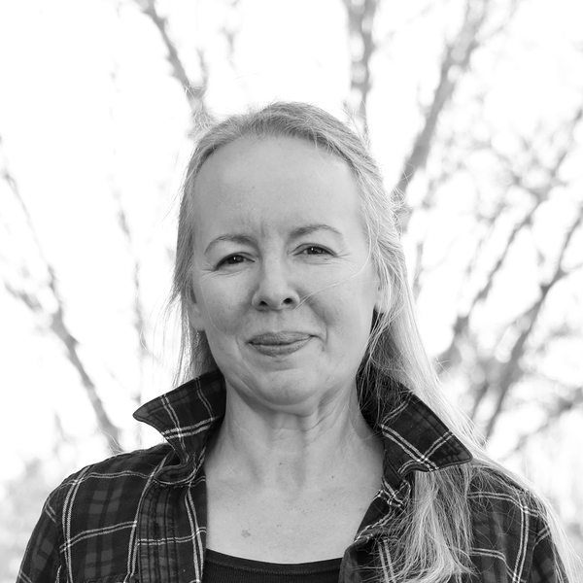

Artist Statement
Melissa Lea Simmons
Melissa paints expressive abstract fine art that brings color, wonder, and heart to life.
I share love, sometimes with paint.

My path to art was shaped by a lifetime of care and service. Before becoming a professional artist, I built and led a pet care business, launched New Hampshire's first pet expo, and founded the New Hampshire Petsitters Association to elevate the industry and the people within it. Later, with a growing desire to serve families in a deeper way, I furthered my education and earned a university degree with teacher certification to teach middle school students.
That path shifted when chronic illness interrupted my plans and led to a long season of disability and healing. During those years, I learned to live more slowly and more intentionally. I learned to grow and preserve food, cook healthy meals, and pay closer attention to what nourishes the soul. Painting emerged from that season of change. What began as a home mural project awakened something unmistakable in me, and I have pursued art with deep commitment ever since.
Today I work in expressive abstraction, using layers of mixed media, color, and mark-making to create movement, atmosphere, and emotional resonance. I paint from imagination without reference, working intuitively to suggest florals, figures, landscapes, domestic memory, or moments of wonder. I am less interested in describing an object exactly than in expressing what it feels like ~ joy, tenderness, energy, rest, delight, and love.
I want my paintings to bring warmth to interiors, heart to daily life, and a sense of connection and care to all who encounter them. Whether bold and playful or quiet and contemplative, each piece is an invitation to pause, feel, and discover.

